Systems Request

Swiftriver’s system request for the construction of a website for Horses Offering Opportunities for the Future. HOOF provides opportunities to children and teens that need emotional and structural support in their lives. With a construction of a website we can help by increasing the business value of HOOF in which they are able to expand their target audience and provide a basis for financial support for their organization. This construction will involve a team of 6 members and may range from 3 to 10 months. These 6 members will provide the required technical skill to construct the website with little risks. This website will provide business value in terms of an increase to donations/grants, volunteers and customers. Information will also add business value in terms of convenience, efficiency and structure. Information will be recorded through signups which makes communicating with customers more efficient. Messages can be sent from members which provides convenience. Donation buttons and reduce time to write grants will also be a direct result of the system. The website will provide technological support that the organization needs and will allow those that are not technologically sound to maneuver the application with ease. This will result in a centralized hub where information from the organization will stored. Once built the website will be used by customers and the organization to communicate events and services.

HOOF KY Website

Vision (Small Project)

Version <2.0>

Revision History

|  |  |  |  |
| --- | --- | --- | --- |
| **Date** | **Version** | **Description** | **Author** |
| 19/January/2018 | 1 | Vision Document Draft 1 | Swiftriver |
| 18/ February/ 2018 | 2 | Vision Document Draft 2 | Swiftriver |
| 28/February/2018 | 3 | Vision Document Draft 3 | Swiftriver |
|  |  |  |  |

Table of Contents

**Introduction** **8**

References 8

**Positioning** **8**

Problem Statement 8

Product Position Statement 8

**Stakeholder and User Descriptions** **8**

Stakeholder Summary 8

User Summary 9

User Environment 10

Summary of Key Stakeholder or User Needs 10

Alternatives and Competition 12

**Product Overview** **12**

Product Perspective 12

Assumptions and Dependencies 12

**Product Features** **12**

**Other Product Requirements** **13**

**Process Models** **15**

**Problem statement** **17**

**Business Case** **19**

**System Requirements** **20**

**Initial Architecture Considerations** **21**

**System Diagrams** **23**

Design View 23

Realization View 24

**Risk Analysis** **25**

**Prototypes** **27**

**Team Charter** **32**

**Gantt Chart** **34**

**Appendix A** **37**

Technical Feasibility 37

Economic Feasibility 37

Organizational Feasibility 40

**Appendix B** **41**

Use Case: Narrative 41

**Use Case: Add Donor** **41**

**Use Case: Modify Donor** **41**

**Use Case: Delete Donor** **42**

**Use Case: Login Donor Profile** **42**

**Use Case: Add One Time Donation** **42**

**Use Case: Add Recurring Donation** **43**

**Use Case: Modify Donation** **43**

**Use Case: Delete Recurring Donation** **43**

**Use Case: View Donations** **44**

**Use Case: Add Children** **44**

**Use Case: Modify Children** **45**

**Use Case: Delete Children** **45**

**Use Case: Add Volunteer** **45**

**Use Case: Modify Volunteer** **46**

**Use Case: Delete Volunteer** **46**

**Use Case: Register Volunteer Profile** **46**

**Use Case: Login Volunteer Profile** **47**

**Use Case: Add Volunteer Hours** **47**

**Use Case: Modify Volunteer Hours** **47**

**Use Case: Delete Volunteer Hours** **48**

**Use Case: Add Event to Calendar** **48**

**Use Case: Modify Event to Calendar** **48**

**Use Case: Delete Event to Calendar** **49**

**Use Case: View Calendar of Events** **49**

**Use Case: Add Fundraising Profits** **49**

**Use Case: Modify Fundraising Profits** **50**

**Use Case: Delete Fundraising Profits** **50**

**Use Case: Add Silent Auction Item** **50**

**Use Case: Modify Silent Auction Item** **51**

**Use Case: Delete Silent Auction Item** **51**

**Use Case: View Silent Auction Item** **51**

**Use Case: Add Silent Auction Sale** **52**

**Use Case: Modify Silent Auction Sale** **52**

**Use Case: Delete Silent Auction Sale** **52**

**Use Case: Add Grant** **53**

**Use Case: Modify Grant** **53**

**Use Case: Delete Grant** **53**

**Use Case: Add Summer Camp Application** **54**

**Use Case: Modify Summer Camp Application** **54**

**Use Case: Delete Summer Camp Application** **55**

**Use Case: View Summer Camp Application** **55**

**Use Case: Register Summer Camp Application** **55**

**Use Case: Add Summer Camp Events** **56**

**Use Case: Modify Summer Camp Events** **56**

**Use Case: Delete Summer Camp Events** **56**

**Use Case: View Summer Camp Events** **57**

**Use Case: Add Horse Data** **57**

**Use Case: Modify Horse Data** **57**

**Use Case: Delete Horse Data** **58**

**Use Case: View Horse Data** **58**

**Use Case: Add Pictures** **58**

**Use Case: Modify Pictures** **59**

**Use Case: Delete Pictures** **59**

**Use Case: Add Newsletter** **59**

**Use Case: Modify Newsletter** **60**

**Use Case: Delete Newsletter** **60**

**Use Case: View Newsletter** **60**

**Use Case: Add Board of Directors Member** **61**

**Use Case: Modify Board of Directors Member** **61**

**Use Case: Delete Board of Directors Member** **61**

**Use Case: View Board of Directors** **62**

**Use Case: Login Board of Directors** **62**

**Trace Matrix** **63**

Vision (Small Project)

# Introduction

The purpose of this document is to collect, analyze, and define high-level needs and features of the HOOF KY website. It focuses on the capabilities needed by the stakeholders and the target users, and **why** these needs exist. The details of how the HOOF KY website fulfills these needs are detailed in the use-case and supplementary specifications.

## References

Hoofkyorg. Retrieved February 07, 2018, from https://www.hoofky.org/

# Positioning

## Problem Statement

HOOF KY currently offers little to no web presence which results in a negative impact on revenue, client and employee convenience.

|  |  |
| --- | --- |
| The problem of | the organization’s poor web presence |
| affects | employees, volunteers and potential donors |
| the impact of which is | lower engagement, less donations and wasted time |
| a successful solution would be | improving the organization’s website and data collection |

## Product Position Statement

For children and teens who are in need of guidance and growth as a person, the HOOF KY website is a tool that will help create bonds and responsibility. Unlike therapy or counselors, our product will help HOOF KY build connections and teach persistence through an efficient site.

|  |  |
| --- | --- |
| For | children and teens |
| Who | in need of guidance and growth as a person |
| The HOOF KY | is a tool |
| That | helps with creating bonds and responsibility |
| Unlike | therapy or counselors |
| Our product | builds connections and teaches persistence |

# Stakeholder and User Descriptions

## Stakeholder Summary

|  |  |  |
| --- | --- | --- |
| **Name** | **Description** | **Responsibilities** |
| Board of Directors | Individual members of the Board of Directors | Ensures the system will be maintainable, monitors the project’s progress, approves funding, |
| Administrators | Administrators organize events, recruit volunteers, oversee website and other system updates | Administrators are responsible for overall business operations and ensuring the website is updated as well as managing the organization |

## User Summary

|  |  |  |  |
| --- | --- | --- | --- |
| **Name** | **Description** | **Responsibilities** | **Stakeholder** |
| Donors | Provide donations to HOOF organization | Responsible for donations through HOOF website, or via mail | Self |
| Volunteers | Support HOOF during events and camps | Responsible for service and time as well as signing up for events and summer camps | Administrators |
| Administrators | Organize events, recruit volunteers, and oversee website | Responsible for providing information on events, summer camps, volunteers, and donors | Self |
| Instructors | Instruct classes and camps for HOOF | Responsible for providing services for HOOF with horse training and education | Administrators |
| Campers | Attends camps and shows | Responsible for participating in activities associated with summer camps and shows | Administrators |

## User Environment

The current user environment consists of administrators performing all the business duties including collecting donations, volunteer sign-ups, event planning, marketing, and collecting other information regarding the organization. This is done by phone, email, mail, and in person. The upgraded website will enable volunteers, instructors, donors, and potential clients to interact with HOOF digitally to ensure their needs are met more efficiently. Administrators are currently storing HOOF’s information on several different laptops and paper. The current model is inconsistent and poses great threats to integrity and security of the data being stored. A centralized database could secure all the data in one place, allowing for a more effective and safer way for the organization to operate. The upgrade to the website will allow administrators to spend time more efficiently on growing the organization by writing more grants and planning more events and camps for HOOF to host.

## Summary of Key Stakeholder or User Needs

|  |  |  |  |  |  |
| --- | --- | --- | --- | --- | --- |
| **Need** | **Priority** | **Concerns** | **Current Solution** | **Proposed Solutions** | |
| Online Donation Option | Primary | There is no online donation option currently available | Donations are made in person or by check via mail | | Create an online donation button integrated to the website to authorize and capture payments using a variety of credit cards and PayPal |
| Volunteer Sign-Up | Primary | There is no way to sign up online through the website | Volunteers are recruited by word of mouth and information sent by email | | Create an online form integrated to the website to enable people to volunteer |
| Social Media/Outreach | Primary | Very limited social media advertising and outreach | Facebook is the only platform utilized and they have a low number of followers | | Utilize several social media platforms for advertising, outreach, events, and points of contact |
| Contact Information | Secondary | Limited amount of contact information | Send an email to the organization and wait for a reply | | Provide more information for visitors of the website including more social media links and possibly a phone number. |
| Donor Management | Secondary | Outdated process of managing donor data | Uses Excel and paper to report donations and donor data | | This system would enable the organization to capture data in one place and be able to retain and advertise more effectively |
| Volunteer Management | Secondary | Outdated process of managing volunteer data | Uses Excel and paper to store information on volunteers | | This system would enable the organization to capture volunteer data in one place making the recruiting process more efficient and retaining volunteers |
| Feedback/Testimonials | Tertiary | No information presented | No way of knowing how the organization is doing and the impact they have on the community | | Provide users on the website and on social media the different ways the organization is helping the community |
| Government/Grant Report | Tertiary | No information presented | Grant reports and other government reporting is done on other computers and paper | | This system will allow HOOF to create reports and documentation highlighting aspects of their organization and other accomplishments |

## Alternatives and Competition

The alternative to upgrading the website is continuing the current status of the website, or getting rid of the website all together. Both options would potentially result in loss of revenue, higher costs, and lost time due to increased work by administrators.

Competition is nonexistent in this case due to the low budget presented by the organization and lack of IT knowledge.

# Product Overview

A centralized database shall benefit the company in terms of service, efficiency, and convenience. The website will serve as the hub for data that will be accessed by the end user as well the IT group. The data stored from customer information will be easily obtained. Convenience applies to both the end user in which their information will be saved, if they choose to, so that payment processes and information would not be entered repeatedly. For the IT group, information will be easily accessed without having to gather all the data from different devices.

Assuming the website is running,we have dependance on the IT group that will keep it running and maintenance to prevent errors. The website should have a 24/7 uptime for convenience but may require weekly to monthly maintenance.

## Product Perspective

This product is mostly self contained, most the the major components such as services, information, and events can be advertised and managed on the website itself. The Payment system that is implemented is partly on the website, but we would be able to create a link to the PS so that the user does not have to visit a different website to fill out their information.

## Assumptions and Dependencies

The website will be created using WordPress or some similar CMS. The data will need to be stored in a database. This database will have storage requirements that need to be addressed via either physical hard drives or cloud storage techniques. There will be a need for someone with minimal technical skills to maintain the website after it has been created.

# Product Features

1. Central Database

* The data of the organization needs to be centralized in one place in order to save both time and money.

1. Electronic Donations

* There needs to be a way to receive donations through the website to increase cash flow.

1. Data Backups

* Need to backup data in a safe place in case of data loss.

1. Marketing

* Without marketing, it would be very hard to find new donors and volunteers for the organization.

1. Social Media

* Social media would enable the organization to reach out to possible donors and provide a source of marketing for free.

1. Volunteer Information / Sign-ups

* Having a volunteer information and sign-up page would enable more volunteers to sign up and find more information about the organization.

1. Easier Communication

* The website needs to provide a method of communication between employees in order to improve efficiency.

1. Event Management

* Having an event management section would allow both employees and users of the website to find out information about upcoming events.

1. Merchandising

* Creating a merchandising section would create a new revenue stream, as well as provide free advertising with labeled products.

# Other Product Requirements

1. Central Database

* This requires the construction of a website such as Wix, which gives us the capabilities to appeal to the audience.
* Maintenance will be required to keep this website running to our future standards.
* Domain Fees
* Basic knowledge of website capabilities.
* This is required since it will provide a central hub for information that will be used to communicate between users and HOOF.

1. Electronic Donations

* A payment system that is either requested or recommended by the client will be used.
* Payment fees may apply
* Important due to the inflow of profit from customers.
* May require constant password changes for security purposes.
* Access to PS should be with trusted and only trusted financial members and or head.

1. Data Backups

* Required weekly or as often as possible to keep information data from being erased.
* We would require a storage area, server, or cloud this is decided by convenience and cost.
* IT to keep data secured and backed up.

1. Marketing

* Costs associated with marketing will depend on the events
* Marketing should appeal to target audience to reduce cost and increase efficiency
* Events dictate what should be advertised and events should be approved by the board and head.
* Largely a whole organization effort.

1. Social Media

* Social media should only be run by a small number or individuals, one should suffice.
* Expanding follower base should be reliant on marketing and only relevant data should be posted.
* Social media should be ran by someone with knowledge of the platform.

1. Volunteer Information / Sign-ups

* Information should be stored in the centralized database.
* Information should be managed by IT
* Sign-ups should be monitored in case of errors
* Important for customer service

1. Easier Communication

* Internal website message should help communication between members
* Important to monitor what is being said, in which doesn't intrude on privacy.
* Requires rules for communication to prevent a hostile environment.

1. Event Management

* Event management should be processed through the board and head
* Important to give information to members to allow spread of information

1. Merchandising

* Important for cash flow but not required.
* Must bring a positive view on the company.

# 

# 

# 

# 

# 

# 

# 

# 

# 

# 

# 

# 

# 

# Process Models

**As Is Model**

This model shows the current business process of HOOF KY. The current processes include mail donations, grants, silent auctions and summer camp information, all recorded on an excel file.

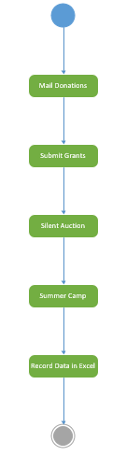

**To be Model**

This model shows what HOOF business processes are seen to be after the project. It is very similar to their current business process, but adding online features and volunteer applications, and all data will be recorded in a database instead of an excel file.

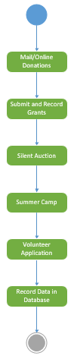

# Problem statement

Horses Offering Opportunities for the Future, or HOOF, is a local non-profit charity located here in Louisville, Ky. The organization offers underprivileged children the chance to partake in mostly emotional therapy by riding and caring for horses during summer camps. Currently the website has basic functions like a contact form and an address that donations can be sent to. What is envisioned for this website is having the ability to donate online directly from the website, finding more information about volunteering and about any upcoming events.

Right now the website has many flaws. There is currently a donation button that does not work. If someone wants to donate to the organization they must find the mailing address on the website and physically send in a donation. This makes it hard for people to donate potentially deterring people from donating. Because of the difficulty, this is a possible loss of funds for the organization. Another problem with the website is the lack of volunteer information. If a potential volunteer goes to the HOOF website hoping to find more information they will leave disappointed. Right now a potential volunteer would need to using the websites contact form to contact HOOF about how to volunteer and hope that they get a reply. This is similar to the problem with donations, when its hard for someone to do something they are less to do it. Making it hard for someone to volunteer for an organization that relies on volunteers is not a good thing. Lastly there is little social media presence for HOOF. They currently have a Facebook page that has very few likes and they lack any other form of social media such as Instagram and Twitter. This is detrimental to the organization because in todays world social media could aid them in spreading awareness about their organization resulting in more volunteers and donations.

These are the most obvious problems with the current HOOF. While the problems may be hurting the organization they can be fixed. For the problem of donations, the most obvious first step would be to get their current donation button working. Moving from only mailing in donations to having the ability to donate online from the website would greatly increase the number of donations that HOOF receives and may even increase the average donation amount. When something is easy to do, people are more likely to do it than if it was hard to do. For their volunteer problem, the current site lacks a tab on their website with information about what volunteers do at HOOF and a sign-up form. This form could possibly be directly submitted on the website or it could be printable and sent in through mail. Either of these would be better than what they currently have, which is nothing about volunteering on their website. Lastly, the problem of social media could be potentially be fixed by creating account on websites such as Instagram and Twitter and having them directly linked on the HOOF website instead of the current version which is social media links to Wix social media. Simply adding these social media accounts to the website is not enough and someone would need to be responsible for running these accounts and they would need to try and spread awareness about HOOF.

Simply put, HOOF currently has a website that is lacking in many ways. They are missing out on potential revenue because of their lack of social media, donation button, and volunteer information. We hope to help HOOF in improving their website to the best of our ability so they may strive and prosper as an organization.

# 

# 

# 

# 

# 

# 

# 

# Business Case

It is not unreasonable to think that with adding a working online donation button to HOOF’s website that total donations would increase. In 2016 HOOF had total fundraising of roughly $15,000 and by adding a donation button that could increase by an estimated 7% leading to $1,050 in extra donations.

HOOF currently has 1 grant for roughly $9,000 and by adding a volunteer sign-up form they could reduce the time they spend looking for volunteers, therefore freeing up time each week they could use to write grants potentially giving them another $9,000.

Lastly, by increasing their social media presence in conjunction with having online donations, HOOF could see a potential increase of 33% on their donations from 2016 ($3,569), giving them an extra $1,070.

|  |  |
| --- | --- |
| Online Donation Button | $1,070 |
| Increased donations by Social Media | $1,050 |
| Increased Grants | $9,000 |
| Total | $11,120 |

# 

# 

# 

# 

# 

# System Requirements

This section provides a list of system requirements that will be implemented. The list is ordered as a hierarchy and is listed in the “shall” format. This format lists the system requirement, and is then followed by what it will accomplish.

1. The central database system shall have all the information in one place to save both time and money.

2. The electronic donation system shall be implemented through the website to increase cash flow.

3. The data backup system shall keep all data secured in case of data loss.

4. The marketing system shall find and attract new donors and volunteers for the organization.

5. The social media system shall enable the organization to reach out to possible donors and provide a source of marketing for free.

6. The new volunteer information / sign-up system shall enable more volunteers to sign up and find more information about the organization.

7. The easier communication system shall provide a method of communication between employees to improve efficiency.

8. The event management system shall allow both employees and users of the website to find out information about upcoming events.

9. The merchandising system shall create a new revenue stream, as well as provide free advertising with labeled products.

# Initial Architecture Considerations

There are several content management and payment systems to consider for the architecture of the HOOF system. These include Content Management Systems (CMS), Payment Systems, and web hosting services that enable the user to run an organization efficiently and effectively.

Content Management Systems such as WordPress and Drupal are great options for creating a website to communicate the mission and objectives of an organization. These are open source systems suited for different needs and present their own strengths and weaknesses. WordPress is straightforward and easy to use, allowing users of any tech background to create a website that provides great functionality and visuals. The design viewpoint of WordPress would allow HOOF to gain access to several template designs that can accommodate different users. This design can easily be integrated with a payment system and web hosting service with a simple click of a button. This would allow HOOF to use donation features for collecting payments, volunteer forms for people interested in service within the organization, and simple, easy options for people to communicate with the organization. With the simplicity of WordPress, it can limit what someone with a background in website design could do with the system. Additional charges may apply if plugins for the website are used as well. Drupal is also a very effective CMS to consider. The design is not quite as impressive as WordPress, but its architecture is flexible. Drupal focuses on security and fosters a social environment such as forums and user blogs. Drupal can also be more difficult to use than WordPress, hindering an organization where technology barriers exist.

Payment Systems to consider are PayPal, Stripe, and Authorize.net. These are all great systems and can easily be integrated within a CMS such as WordPress and Drupal. They are all great payment systems and are PCI compliant. Encryption is used for each transaction and security is top notch for all platforms. They all charge 2.9% + $0.30 per transaction. PayPal offers nonprofit discounts and no hidden fees. The most notable weakness is the time it takes for payments to clear and process to your bank account. Authorize.net is one of the most popular payment systems, but charges a monthly fee as well as a set-up fee of $49. Stripe on the other hand, has no set-up fees, monthly fees, or hidden costs and charges the same amount per transaction as Authorize.net and PayPal. Stripe also offers SQL features and is one of the most popular payment gateways for QuickBooks.

Web hosting services to consider are Bluehost and SiteGround. Both services offer packages ranging from $3.95/month to $30/month and are highly recommended by CMS such as WordPress and Drupal. Bluehost is very popular and hosts over 2 million domains to date. They offer 24/7 support with free domain and free SSL Certificate. The downfall with Bluehost is the basic package of web hosting is shared with other users which can result in slower speeds. SiteGround offers the same features as Bluehost. SiteGround also offers unlimited SQL Database and you can start with a small plan and upgrade as your organization grows. The promotional price for SiteGround is $3.95/month and with Bluehost it is $19.95/month. The storage capacity for each host varies depending on the package. The low end for SiteGround is 10GB of space and for Bluehost it is 30GB. Each web hosting are great options depending on the organization’s needs, size, and potential growth.

The most common and easiest CMS to use would be WordPress. Integrating PayPal and/or Stripe to this CMS would be simple and easy for someone with very little technological skills. Using SiteGround for web hosting would be ideal in this situation considering the flexibility and growth within the organization. HOOF would not be forced to pay for a service which provides more than they need. With SiteGround, HOOF could upgrade over time if needed and eventually still pay less ($11.95/month for premium). With mostly the same features as Bluehost, as well as the SQL capabilities and excellent customer service rating, SiteGround seems to be an ideal fit for HOOF’s web hosting needs at a reasonable price.

# System Diagrams

## Design View

Users interact with the HOOF website hosted by a server to provide functionality. Firewalls are in place to control incoming and outgoing traffic based on predetermined security rules to prevent unauthorized access. Data is stored in a centralized database to ensure security and authorized access to sensitive information.

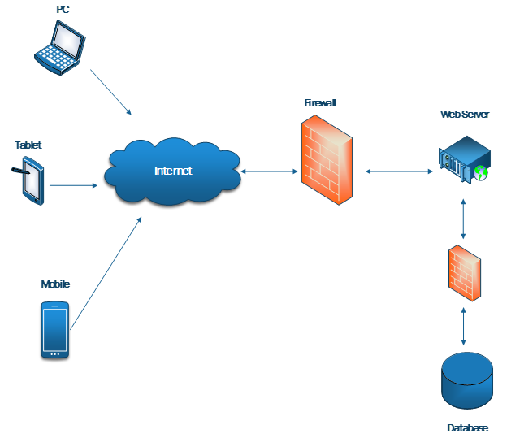

## Realization View

Users are identified and interact with the HOOF website developed through WordPress and hosted on a server via SiteGround. Firewalls are in place to ensure the network is secure and serves as a barrier to untrusted networks such as the Internet. Data from the website is stored in the database for centralized access. Backup copies of the data are stored to protect and restore the database.

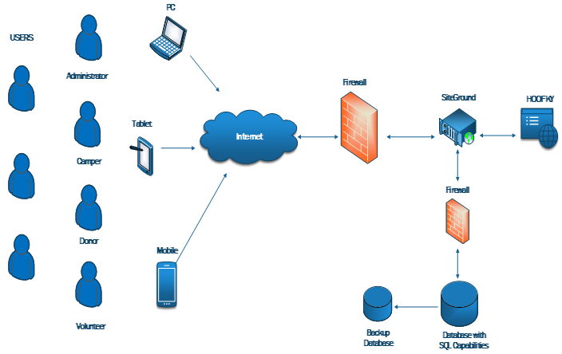

# 

# 

# Risk Analysis

**Criteria Definition: Case**

This analysis defines whether a case is a high or low risk. High risk cases are any cases that involve any financial process, what can bring cash flow to HOOF, and will help the most with HOOF’s business/organizational process. These cases should be of high priority as the sooner these are implemented, the better financial position HOOF will have. Low risk cases are cases that do not involve any financial process, but will help for some functionality for HOOF.

**High**

* Donations
* Children
* Fundraising
* Silent auctions
* Grants
* Summer Camp

**Low**

* Donor
* Volunteer
* Board of Directors
* Events
* Horse Data
* Pictures
* Newsletters

**Criteria Definition: Items**

This analysis defines whether an item is a high or low risk. High risk items are items that involve any financial process, what can bring cash flow to HOOF, and will help the most with HOOF’s business/organizational process. These cases should be of high priority as the sooner these are implemented, the better financial position HOOF will have. Low risk items are items that do not involve any financial process, but will help for some functionality for HOOF.

**High**

* Data Entry
* PayPal
* WordPress

**Low**

* Events Calendar
* Photo Gallery
* Contacts Page
* Newsletter Archive

**Risks in Elaboration Phase**

These risks may be useful to address in the Elaboration phase because it shows which cases and items should be fixed and implemented. By applying the high risks and items first, HOOF will have a basic design and architecture that will make it easier for the users and the organization to use. Then, low cases and items will be added later on to add depth to the site and will make the site have a look and feel of a reputable site. Overall, these cases will help prioritize what needs to be implemented first. Refer to Appendix A for feasiblity. Refer to Appendix B for use cases.

# Prototypes

# 

**Homepage:**

We’ve reduced the size of the website’s header image, and added panes for HOOF’s mission statement/”who we are” and event location/descriptions. We’ve also added a calendar that interacts with the event list to dynamically display information to users who want to know what is happening, where it is happening, and when it is happening.

We’ve also added a donation button directly to the front page, as well as direct links to HOOF’s social media (Facebook, Instagram, Twitter).

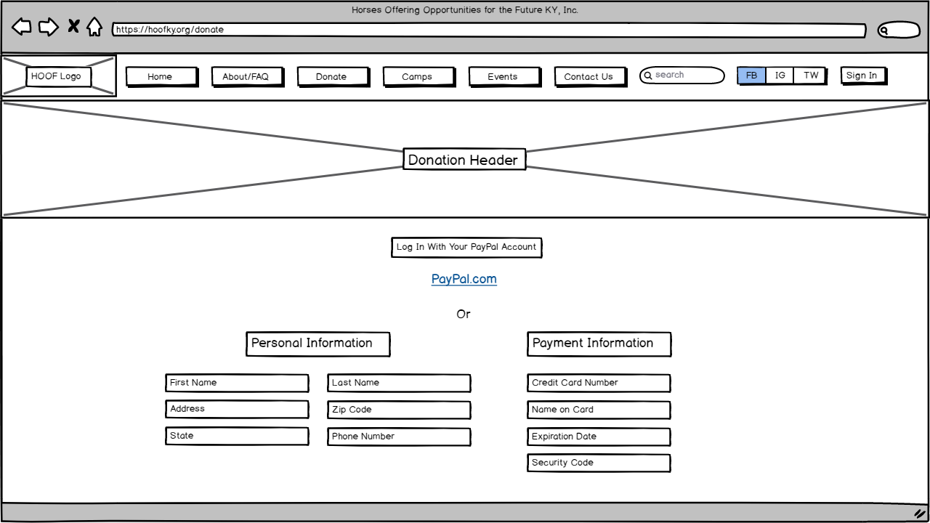

**Donation Form:**

The donation form mostly resembles the homepage in terms of the header image and the navigation pane. We’ve added a direct link through to PayPal for payment processing, and have also included fields for manual entry of credit card information.

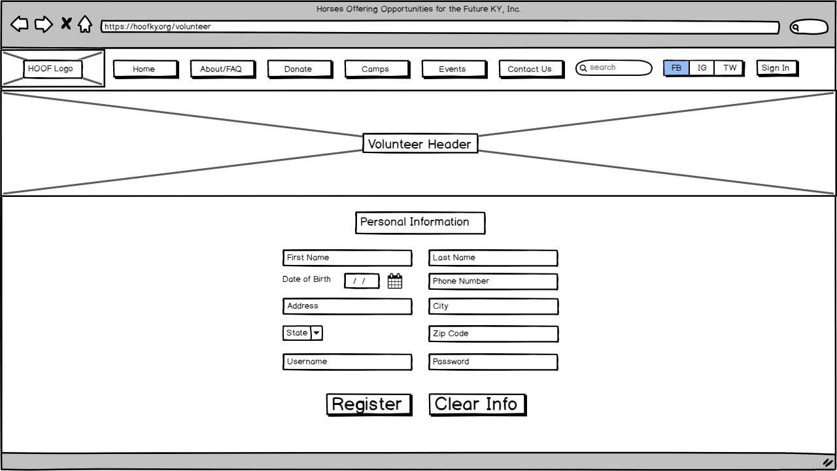

**Volunteer Form:**

The volunteer form mostly resembles the homepage in terms of the header image and the navigation pane. This page contains a set of simple text fields through which users can create user accounts.

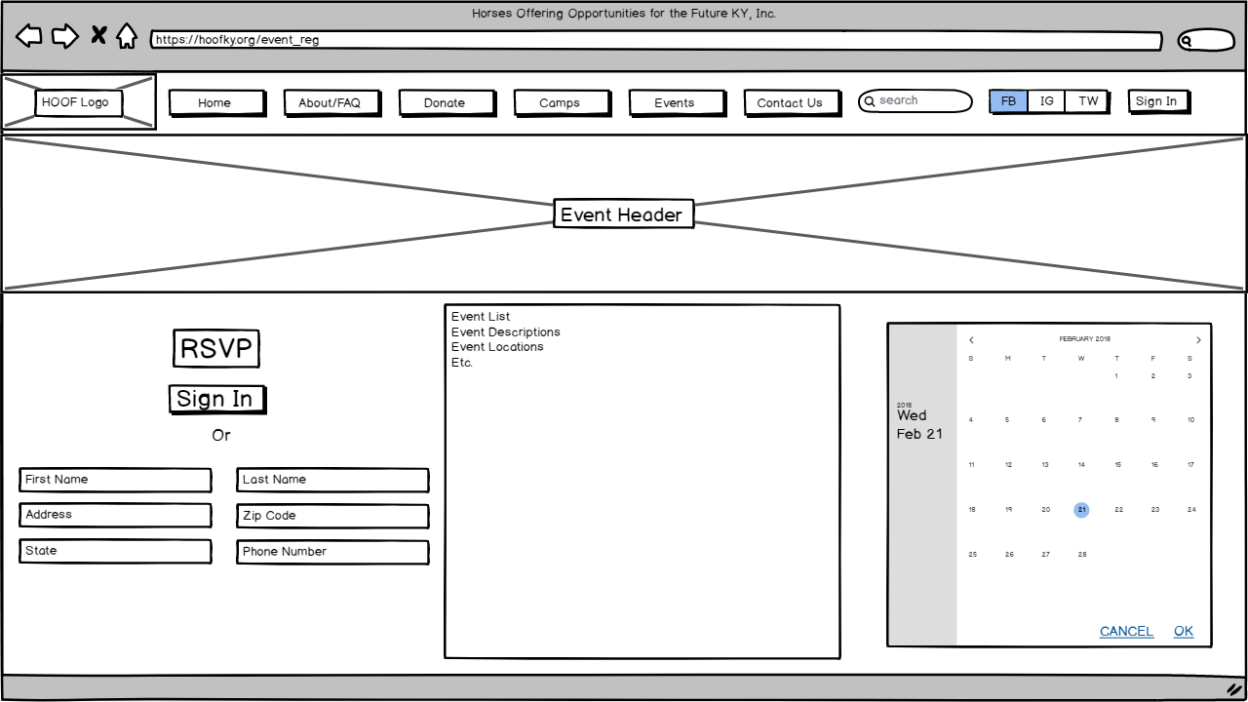

**Event Registration Form:**

The event registration form mostly resembles the homepage in terms of the header image and the navigation pane. This page contains a date picker that interacts with the same event location/description pane that’s present on the homepage; it also contains a set of fields for manual event registration, or a button that will allow users to log in using their user account and register that way with their existing account information.

# 

# 

# Team Charter

**Team Purpose and Goals**

This team will perform technical and financial analysis on the IT operations of HOOF KY and perform consultations with the purpose of improving the usability and engagement of their online presence. We will provide the organization with deliverables outlining the methods by which they can potentially improve the efficiency of their operations.

**Duration and Time Commitment**

This team has been brought together for the length of one semester (January to April). The group will attempt to put at least 5 hours a week individually into the project, in accordance with balancing the course load that we have as students.

**Scope**

Activities that involve online-exclusive assets such as the website, the content management system and the payment processing system can all be considered in scope. Activities that involve direct manipulation of the organization’s private user data as well as hardware such as servers are out of scope.

**Members**

Trisia Baltazar

Adrian Boone – Developer

Chad Daily

Jann Jalando-on

Mate Kovacs

Joseph Morrison

**Deliverables**

The team will deliver a series of documents outlining the deficiencies that we have identified in the current IT environment of HOOF KY, as well as documents outlining our suggested changes and projected/estimated benefits that implementing the team’s suggestions will result in.

**Team Meetings**

Meetings will be discussed and scheduled through online communications (primarily email) and group chat applications (Slack and GroupMe).

Meetings will be conducted with an informal structure; the team has decided on a relatively leaderless organization and does not intend to follow rigid agendas.

Meeting decisions will be documented internally through the use of personal laptop computers.

**Team Communications**

Team communications will be facilitated through online communications (primarily email) and group chat applications (Slack and GroupMe). This will include scheduling discussions as well as the transfer of necessary materials and documentation.

Communications between the team and the client, as well as between the team and the instructor, will be facilitated through email or in-person meetings during office hours as necessary.

**Team Decisions**

The team will build consensus through thorough discussion of the project and make decisions as a unit.

The team will handle any necessary conflicts through mediation with the instructor, if necessary.

**Project Repository**

Project documentation will be maintained on each user’s personal machine as necessary, with redundant backups present in the cloud (Google Drive and OneDrive).

The team will, if required, set up a Github repository for further storage.

# Gantt Chart

Both of these charts have the name of the task and the name of the group member performing the task to the left of the chart. Each task has a bar that indicated the length of the task, measured in days. Some tasks are independent and can be started whenever while others are dependent and require certain tasks be completed before they can be started. A dependent task is indicated by its starting point being at the end of another task instead of being on the first day like the other tasks. Where the bar starts indicates which task it depends on.

The I2 Gantt chart shows that the dependent tasks are the use cases and the risk analysis. The I3 Gantt chart shows that the dependent tasks are Use Case Diagram and the Use Case Prototype.

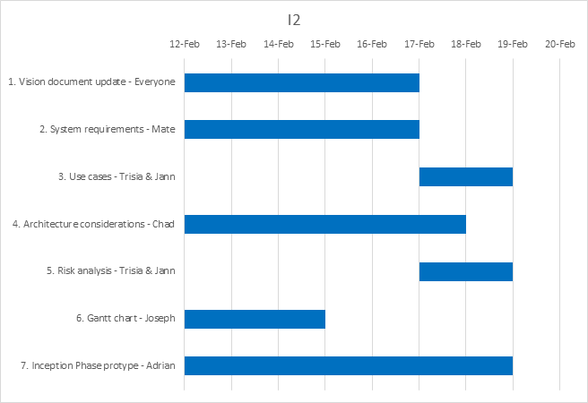

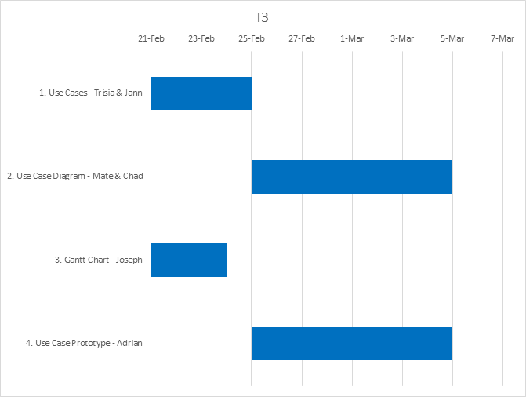

# Appendix A

**Feasibility Considerations**

## Technical Feasibility

**Familiarity With Functional Area:** We as a team are familiar with what HOOF needs from their system. The users of the system should be able to use it with little to no problems because of the simplicity of the system that is being built.

**Familiarity With Technology:** Currently HOOF does not have a system like what we are proposing so there is some risk in them not being familiar with the technology. While these is some risk in this area, the system we plan on building should be simple enough that they could operate it with their current technical knowledge.

**Project Size:** The team that is working on this system is composed of 6 people and the length of the project is roughly 3-4 months. Because our team is small and the project is short there should be little risk.

**Compatibility:** HOOF currently does not have any systems like what we plan on building so there should be little risk with integrating out system with their current systems.

## Economic Feasibility

|  |  |
| --- | --- |
| Development Costs | |
| Team Salaries | $0 |
| Fees | $0 |

|  |  |
| --- | --- |
| Annual Operating Costs | |
| CMS Costs | $250 |
| PMS Costs | 2.9% + $0.30 per transaction |

|  |  |
| --- | --- |
| Benefits | |
| Online Donation Button | $1,130 |
| Volunteer Sign-Up, allows for more grants | $9,000 |
| Social Media Presence, more donations | $1,070 |

|  |  |
| --- | --- |
| Intangible Benefits | |
| Increased Brand Recognition |  |
| Increased Awareness of Problem HOOF solves |  |

|  |  |  |  |  |  |  |
| --- | --- | --- | --- | --- | --- | --- |
|  | Year 1 | Year 2 | Year 3 | Year 4 | Year 5 | Total |
| Online Donation Button/ Social Media | 2,120 | 2,160 | 2,210 | 2,250 | 2,290 |  |
| Increased Grants | 9,000 | 9,180 | 9,360 | 9,550 | 9,740 |  |
| Current Donations | 3,570 | 3,640 | 3,710 | 3,790 | 3,860 |  |
| Total | 14,690 | 14,980 | 15,280 | 15,590 | 15,890 |  |
| **PV of Benefits** | **$13,670** | **$12,960** | **$12,300** | **$11,680** | **$11.070** | **$61,680** |
| **PV of All Benefits** | **$13,670** | **$26,630** | **$38,930** | **$50,610** | **$61,680** |  |
| Hardware | 5,500 | 0 | 0 | 0 | 0 |  |
| Labor | 0 | 0 | 0 | 0 | 0 |  |
| Total Developmental Costs | 5,500 | 0 | 0 | 0 | 0 |  |
| CMS | 200 | 200 | 210 | 210 | 220 |  |
| PS | 180 | 180 | 190 | 190 | 200 |  |
| Total Operational Costs | 380 | 380 | 400 | 400 | 420 |  |
| Total Costs | 5,880 | 380 | 400 | 400 | 420 |  |
| **PV of Costs** | **$5,470** | **$330** | **$320** | **$300** | **$290** | **$6,710** |
| **PV of All Costs** | **$5,470** | **$5,800** | **$6,120** | **$6,420** | **$6,710** |  |
| **Total Benefits – Total Costs** | **$8,810** | **$14,600** | **$14,880** | **$15,190** | **$15,470** |  |
| **Yearly NPV** | **$8,200** | **$12,630** | **$11,980** | **$11,380** | **$10,770** | **$54,960** |
| **Cumulative NPV** | **$8,200** | **$20,830** | **$32,810** | **$44,190** | **$54,960** |  |
| ROI | 819% |  |  |  |  |  |
| Break Even | During Year 1 |  |  |  |  |  |

## Organizational Feasibility

**Champion:** Suzanne Meeks.

Role: Starts the project, provides resources.

**Organizational Management:** Suzanne Meeks, Board of Directors.

Role: Budget for the project, guides the project, helps integrate system into organization.

**Users:** Donors, Volunteers, HOOF Employees, users of HOOFs services.

Role: influences decisions made about project, decides if project was a success, uses the system.

# Appendix B

## Use Case: Narrative

The following chart describes how to read each diagram for the use cases.

|  |  |
| --- | --- |
| ID: | Displays a unique identifier for the Use Case. |
| Use Case Name: | Displays the name of the Use Case. |
| Primary Actor(s): | Displays the people who will be directly affected by or will directly affect the case. |
| Risk Level: | Displays the importance of the case. |
| Description: | Briefly describes what the case is about. |

# 

# Use Case: Add Donor

|  |  |
| --- | --- |
| ID: | 1.A |
| Use Case Name: | Add Donor |
| Primary Actor(s): | Donor |
| Risk Level: | Low |
| Description: | This use case describes how donors make an account. |

# Use Case: Modify Donor

|  |  |
| --- | --- |
| ID: | 1.B |
| Use Case Name | Modify Donor |
| Primary Actor(s): | Donor |
| Risk Level: | Low |
| Description: | This use case describes how donors change account information and perform other modifications. |

# Use Case: Delete Donor

|  |  |
| --- | --- |
| ID: | 1.C |
| Use Case Name:: | Delete Donor |
| Primary Actor(s): | Donor |
| Risk Level: | Low |
| Description: | This use case describes how donors delete their account. |

# 

# Use Case: Login Donor Profile

|  |  |
| --- | --- |
| ID: | 1.D |
| Use Case Name:: | Login Donor Profile |
| Primary Actor(s): | Donor |
| Risk Level: | Low |
| Description: | This use case describes how donors can login to their profiles. |

# 

# Use Case: Add One Time Donation

|  |  |
| --- | --- |
| ID: | 2.A |
| Use Case Name:: | Add One Time Donation |
| Primary Actor(s): | Donor |
| Risk Level: | High |
| Description: | This use case describes how donors enters a one time donation amount. |

# Use Case: Add Recurring Donation

|  |  |
| --- | --- |
| ID: | 2.B |
| Use Case Name:: | Add Recurring Donation |
| Primary Actor(s): | Donor |
| Risk Level: | High |
| Description: | This use case describes how donors enter a recurring donation amount. |

# Use Case: Modify Donation

|  |  |
| --- | --- |
| ID: | 2.C |
| Use Case Name:: | Modify Recurring Donation |
| Primary Actor(s): | Donor |
| Risk Level: | High |
| Description: | This use case describes how donors can change their recurring donation amount. |

# Use Case: Delete Recurring Donation

|  |  |
| --- | --- |
| ID: | 2.D |
| Use Case Name:: | Delete Recurring Donation |
| Primary Actor(s): | Donation |
| Risk Level: | High |
| Description: | This use case describes how donors can delete their recurring donation amount. |

# Use Case: View Donations

|  |  |
| --- | --- |
| ID: | 2.D |
| Use Case Name:: | View donations |
| Primary Actor(s): | Donor |
| Risk Level: | High |
| Description: | This use case describes how donors to view their donation history. |

# 

# Use Case: Add Children

|  |  |
| --- | --- |
| ID: | 3.A |
| Use Case Name:: | Add Children |
| Primary Actor(s): | Parents/Guardians, Admins |
| Risk Level: | High |
| Description: | This use case describes how Parents/Guardians and admin can add children information. |

# Use Case: Modify Children

|  |  |
| --- | --- |
| ID: | 3.B |
| Use Case Name:: | Modify Children |
| Primary Actor(s): | Parents/Guardians, Admin |
| Risk Level: | High |
| Description: | This use case describes how Parents/Guardians and admin can modify children information. |

# Use Case: Delete Children

|  |  |
| --- | --- |
| ID: | 3.C |
| Use Case Name:: | Add |
| Primary Actor(s): | Parents/Guardians, admin |
| Risk Level: | High |
| Description: | This use case describes how Parents/Guardians and admin can delete children information. |

# Use Case: Add Volunteer

|  |  |
| --- | --- |
| ID: | 4.A |
| Use Case Name:: | Add Volunteer |
| Primary Actor(s): | Volunteer |
| Risk Level: | Low |
| Description: | This use cases describes how a volunteer adds information |

# Use Case: Modify Volunteer

|  |  |
| --- | --- |
| ID: | 4.B |
| Use Case Name:: | Modify Volunteer |
| Primary Actor(s): | Volunteer |
| Risk Level: | Low |
| Description: | This use cases describes how a volunteer modifies their information. |

# Use Case: Delete Volunteer

|  |  |
| --- | --- |
| ID: | 4.C |
| Use Case Name:: | Delete Volunteer |
| Primary Actor(s): | Volunteer |
| Risk Level: | Low |
| Description: | This use cases describes how a volunteer deletes their information. |

# Use Case: Register Volunteer Profile

|  |  |
| --- | --- |
| ID: | 4.D |
| Use Case Name:: | Register Volunteer Profile |
| Primary Actor(s): | Volunteer |
| Risk Level: | Low |
| Description: | This use cases describes how a volunteer can register for a profile |

# Use Case: Login Volunteer Profile

|  |  |
| --- | --- |
| ID: | 4.E |
| Use Case Name:: | Login Volunteer Profile |
| Primary Actor(s): | Volunteer |
| Risk Level: | Low |
| Description: | This use cases describes how a volunteer can login to their profile. |

# 

# Use Case: Add Volunteer Hours

|  |  |
| --- | --- |
| ID: | 5.A |
| Use Case Name:: | Add Volunteer Hours |
| Primary Actor(s): | Volunteer |
| Risk Level: | Low |
| Description: | This use case describes how a volunteer can enter volunteer hours. |

# Use Case: Modify Volunteer Hours

|  |  |
| --- | --- |
| ID: | 5.B |
| Use Case Name:: | Modify Volunteer Hours |
| Primary Actor(s): | Volunteer |
| Risk Level: | Low |
| Description: | This use case describes how a volunteer can modify volunteer hours. |

# Use Case: Delete Volunteer Hours

|  |  |
| --- | --- |
| ID: | 5.C |
| Use Case Name:: | Delete Volunteer Hours |
| Primary Actor(s): | Volunteer |
| Risk Level: | Low |
| Description: | This use case describes how a volunteer can delete volunteer hours. |

# 

# Use Case: Add Event to Calendar

|  |  |
| --- | --- |
| ID: | 6.A |
| Use Case Name:: | Add Event to Calendar |
| Primary Actor(s): | Admin |
| Risk Level: | Low |
| Description: | This use case describes how an admin can add an event to the event calendar. |

# Use Case: Modify Event to Calendar

|  |  |
| --- | --- |
| ID: | 6.B |
| Use Case Name:: | Modify Event to Calendar |
| Primary Actor(s): | Admin |
| Risk Level: | Low |
| Description: | This use case describes how an admin can modify an event on the event calendar. |

# Use Case: Delete Event to Calendar

|  |  |
| --- | --- |
| ID: | 6.C |
| Use Case Name:: | Delete Event to Calendar |
| Primary Actor(s): | Admin |
| Risk Level: | Low |
| Description: | This use case describes how an admin can delete an event on the event calendar. |

# Use Case: View Calendar of Events

|  |  |
| --- | --- |
| ID: | 6.D |
| Use Case Name:: | View Calendar of Events |
| Primary Actor(s): | User |
| Risk Level: | Low |
| Description: | This use case describes how user can view events. |

# 

# Use Case: Add Fundraising Profits

|  |  |
| --- | --- |
| ID: | 7.A |
| Use Case Name:: | Add Fundraising Profits |
| Primary Actor(s): | Admin |
| Risk Level: | High |
| Description: | This use case describes how an admin can add profit from fundraising events. |

# Use Case: Modify Fundraising Profits

|  |  |
| --- | --- |
| ID: | 7.B |
| Use Case Name:: | Modify Fundraising Profits |
| Primary Actor(s): | Admin |
| Risk Level: | High |
| Description: | This use case describes how an admin can modify profit from fundraising events. |

# Use Case: Delete Fundraising Profits

|  |  |
| --- | --- |
| ID: | 7.C |
| Use Case Name:: | Delete Fundraising Profits |
| Primary Actor(s): | Admin |
| Risk Level: | High |
| Description: | This use case describes how an admin can delete profit from fundraising events. |

# 

# Use Case: Add Silent Auction Item

|  |  |
| --- | --- |
| ID: | 8.A |
| Use Case Name:: | Add Silent Auction Item |
| Primary Actor(s): | Admin |
| Risk Level: | Low |
| Description: | This use case describes how an admin can add a silent auction item. |

# Use Case: Modify Silent Auction Item

|  |  |
| --- | --- |
| ID: | 8.B |
| Use Case Name:: | Modify Silent Auction Item |
| Primary Actor(s): | Admin |
| Risk Level: | Low |
| Description: | This use case describes how an admin can modify a silent auction item. |

# Use Case: Delete Silent Auction Item

|  |  |
| --- | --- |
| ID: | 8.C |
| Use Case Name:: | Delete Silent Auction Item |
| Primary Actor(s): | Admin |
| Risk Level: | Low |
| Description: | This use case describes how an admin can delete a silent auction item. |

# Use Case: View Silent Auction Item

|  |  |
| --- | --- |
| ID: | 8.D |
| Use Case Name:: | View Silent Auction Item |
| Primary Actor(s): | User |
| Risk Level: | Low |
| Description: | This use case describes how a user can view silent auction items. |

# Use Case: Add Silent Auction Sale

|  |  |
| --- | --- |
| ID: | 9.A |
| Use Case Name:: | Add Silent Auction Sale |
| Primary Actor(s): | Admin |
| Risk Level: | High |
| Description: | This use case describes how an admin can add a silent auction profit if item is sold. |

# Use Case: Modify Silent Auction Sale

|  |  |
| --- | --- |
| ID: | 9.B |
| Use Case Name:: | Modify Silent Auction Sale |
| Primary Actor(s): | Admin |
| Risk Level: | High |
| Description: | This use case describes how an admin can modify a silent auction profit if item is sold. |

# Use Case: Delete Silent Auction Sale

|  |  |
| --- | --- |
| ID: | 9.C |
| Use Case Name:: | Delete Silent Auction Sale |
| Primary Actor(s): | Admin |
| Risk Level: | High |
| Description: | This use case describes how an admin can delete a silent auction profit if item is sold. |

# 

# Use Case: Add Grant

|  |  |
| --- | --- |
| ID: | 10.A |
| Use Case Name:: | Add Grant |
| Primary Actor(s): | Admin |
| Risk Level: | High |
| Description: | This use case describes how an admin can add Grant data. |

# Use Case: Modify Grant

|  |  |
| --- | --- |
| ID: | 10.B |
| Use Case Name:: | Modify Grant |
| Primary Actor(s): | Admin |
| Risk Level: | High |
| Description: | This use case describes how an admin can modify Grant data. |

# Use Case: Delete Grant

|  |  |
| --- | --- |
| ID: | 10.C |
| Use Case Name:: | Delete Grant |
| Primary Actor(s): | Admin |
| Risk Level: | High |
| Description: | This use case describes how an admin can delete Grant data. |

# Use Case: Add Summer Camp Application

|  |  |
| --- | --- |
| ID: | 11.A |
| Use Case Name:: | Add Summer Camp Application |
| Primary Actor(s): | Admin |
| Risk Level: | Low |
| Description: | This use case describes how an admin can add a summer camp application form. |

# Use Case: Modify Summer Camp Application

|  |  |
| --- | --- |
| ID: | 11.B |
| Use Case Name:: | Modify Summer Camp Application |
| Primary Actor(s): | Admin |
| Risk Level: | Low |
| Description: | This use case describes how an admin can modify a summer camp application form. |

# Use Case: Delete Summer Camp Application

|  |  |
| --- | --- |
| ID: | 11.C |
| Use Case Name:: | Delete Summer Camp Application |
| Primary Actor(s): | Admin |
| Risk Level: | Low |
| Description: | This use case describes how an admin can delete a summer camp application. |

# Use Case: View Summer Camp Application

|  |  |
| --- | --- |
| ID: | 11.D |
| Use Case Name:: | View Summer Camp Application |
| Primary Actor(s): | User |
| Risk Level: | Low |
| Description: | This use case describes how a user can view the summer camp application. |

# Use Case: Register Summer Camp Application

|  |  |
| --- | --- |
| ID: | 11.E |
| Use Case Name:: | Register Summer Camp Application |
| Primary Actor(s): | User |
| Risk Level: | Low |
| Description: | This use case describes how a user can register for summer camp via application. |

# 

# Use Case: Add Summer Camp Events

|  |  |
| --- | --- |
| ID: | 12.A |
| Use Case Name:: | Add Summer Camp Events |
| Primary Actor(s): | Admin |
| Risk Level: | Low |
| Description: | This use case describes how an admin can add a summer camp event. |

# Use Case: Modify Summer Camp Events

|  |  |
| --- | --- |
| ID: | 12.B |
| Use Case Name:: | Modify Summer Camp Events |
| Primary Actor(s): | Admin |
| Risk Level: | Low |
| Description: | This use case describes how an admin can modify a summer camp event. |

# Use Case: Delete Summer Camp Events

|  |  |
| --- | --- |
| ID: | 12.C |
| Use Case Name:: | Delete Summer Camp Events |
| Primary Actor(s): | Admin |
| Risk Level: | Low |
| Description: | This use case describes how an admin can delete a summer camp event. |

# Use Case: View Summer Camp Events

|  |  |
| --- | --- |
| ID: | 12.D |
| Use Case Name:: | Delete Summer Camp Events |
| Primary Actor(s): | User |
| Risk Level: | Low |
| Description: | This use case describes how a user can view summer camp events. |

# Use Case: Add Horse Data

|  |  |
| --- | --- |
| ID: | 13.A |
| Use Case Name:: | Add Horse Data |
| Primary Actor(s): | Admin |
| Risk Level: | Low |
| Description: | This use case describes how an admin can add horse data. |

# Use Case: Modify Horse Data

|  |  |
| --- | --- |
| ID: | 13.B |
| Use Case Name:: | Modify Horse Data |
| Primary Actor(s): | Admin |
| Risk Level: | Low |
| Description: | This use case describes how an admin can modify horse data. |

# Use Case: Delete Horse Data

|  |  |
| --- | --- |
| ID: | 13.C |
| Use Case Name:: | Delete Horse Data |
| Primary Actor(s): | Admin |
| Risk Level: | Low |
| Description: | This use case describes how an admin can delete horse data. |

# Use Case: View Horse Data

|  |  |
| --- | --- |
| ID: | 13.D |
| Use Case Name:: | View Horse Data |
| Primary Actor(s): | User |
| Risk Level: | Low |
| Description: | This use case describes how a user can view horse data. |

# Use Case: Add Pictures

|  |  |
| --- | --- |
| ID: | 14.A |
| Use Case Name:: | Add Pictures |
| Primary Actor(s): | Admin |
| Risk Level: | Low |
| Description: | This use case describes how an admin can add pictures to the site. |

# Use Case: Modify Pictures

|  |  |
| --- | --- |
| ID: | 14.B |
| Use Case Name:: | Modify Pictures |
| Primary Actor(s): | Admin |
| Risk Level: | Low |
| Description: | This use case describes how an admin can modify pictures on the site. |

# Use Case: Delete Pictures

|  |  |
| --- | --- |
| ID: | 14.C |
| Use Case Name:: | Add Pictures |
| Primary Actor(s): | Admin |
| Risk Level: | Low |
| Description: | This use case describes how an admin can delete pictures to the site. |

# Use Case: Add Newsletter

|  |  |
| --- | --- |
| ID: | 15.A |
| Use Case Name:: | Add Newsletter |
| Primary Actor(s): | Admin |
| Risk Level: | Low |
| Description: | This use case describes how an admin can add a newsletter. |

# Use Case: Modify Newsletter

|  |  |
| --- | --- |
| ID: | 15.B |
| Use Case Name:: | Modify Newsletter |
| Primary Actor(s): | Admin |
| Risk Level: | Low |
| Description: | This use case describes how an admin can modify a newsletter. |

# Use Case: Delete Newsletter

|  |  |
| --- | --- |
| ID: | 15.C |
| Use Case Name:: | Delete Newsletter |
| Primary Actor(s): | Admin |
| Risk Level: | Low |
| Description: | This use case describes how an admin can delete a newsletter. |

# Use Case: View Newsletter

|  |  |
| --- | --- |
| ID: | 15.D |
| Use Case Name:: | Delete Newsletter |
| Primary Actor(s): | User |
| Risk Level: | Low |
| Description: | This use case describes how a user can view the newsletter. |

# Use Case: Add Board of Directors Member

|  |  |
| --- | --- |
| ID: | 16.A |
| Use Case Name:: | Add Board of Directors Member |
| Primary Actor(s): | Admin |
| Risk Level: | Low |
| Description: | This use case describes how an admin can add a new board of Directors Member to the Board of Directors page. |

# Use Case: Modify Board of Directors Member

|  |  |
| --- | --- |
| ID: | 16.B |
| Use Case Name:: | Modify Board of Directors Member |
| Primary Actor(s): | Admin |
| Risk Level: | Low |
| Description: | This use case describes how an admin can modify a board of Directors Member information on the Board of Directors page. |

# Use Case: Delete Board of Directors Member

|  |  |
| --- | --- |
| ID: | 16.C |
| Use Case Name:: | Delete Board of Directors Member |
| Primary Actor(s): | Admin |
| Risk Level: | Low |
| Description: | This use case describes how an admin can delete a new Board of Directors Member on the Board of Directors page. |

# Use Case: View Board of Directors

|  |  |
| --- | --- |
| ID: | 16.D |
| Use Case Name:: | Add Board of Directors Member |
| Primary Actor(s): | User |
| Risk Level: | Low |
| Description: | This use case describes how a user can view the Board of Directors Member. |

# Use Case: Login Board of Directors

|  |  |
| --- | --- |
| ID: | 16.E |
| Use Case Name:: | Add Board of Directors Member |
| Primary Actor(s): | User |
| Risk Level: | Low |
| Description: | This use case describes how a user can login to their Board of Directors Profile. |

# Trace Matrix

The trace matrix is a representation of how these use cases are related to the system requirements. Relationships are marked with an “X.” The first column lists the use cases and the first row lists the system requirements.

